Gradient Descent

14.33 - Introduction to gradient descent

Inching ever closer to a proper modern outline of a current machine learning algorithm, we finally arrive at what is perhaps the most fundamental technique used in all manner of machine learning models: gradient descent. Although our linear regression models could be estimated in closed form using a statistical or algebraic approach, any model that is marginally more complex (and therefore likely to be more interesting and useful) requires a new approach. We can no longer rely on estimating our parameters in a deterministic way. Instead, we will have to iterate, finding our way carefully through a complicated landscape of parameters and performance they offer. Framed in this way, machine learning equates to optimization: the process of adjusting the algorithm's parameters to minimize the difference between what we observe and what the algorithm predicts. To successfully optimize our parameters relative to the vast landscape of possible models and parameters, we will need to decide where to start, where to move next, how far to move, and when to stop moving. And the most important decision within this framework is where to move next: given our current parameters, our input data, and our output data, how do we change or update these parameters for them to become more optimal and yield better predictions across all the available inputs we have to our disposal?

14.34 - Getting all our ducks in a row
There are a few prerequisites to start implementing gradient descent, all of which we have already discussed. Optimization means error minimization, which in turn forces us to quantify the related concepts of error and model performance. We formalized a machine learning model previously as function f, parameterized by weights theta. This function yields an optimal mapping of input data X to the output variable y. We further distinguished between the output of our model as the prediction (also sometimes called the hypothesis h) and the difference between our prediction and the objective outcome associated with the current input as the error. The metric loss was introduced to capture the performance of our model, given the current parameters theta. During training, we aim to adjust parameters theta such that the loss is minimized. Within the context of linear regression, the way we compute loss is very similar to how we computed the Sum of Squares Error, or the amount of variance left unexplained by our machine learning model. In the next chapter, we will see that we will need to compute loss differently for other types of machine learning models (e.g., classifiers). These are all the ingredients we need to implement gradient descent.

14.35 - Loss Landscapes Revisited
In the previous section, we introduced the idea of a loss landscape. In theory, we can create an N-dimensional space in which each dimension represents a parameter of our model. Each point in such a space thus presents a set of parameter values that specify our model. At the same time, a particular set of parameters is associated with a particular loss value. It is impractical, if not outright impossible, to plot its loss landscape for any real-world model. Not only do we have trouble visualizing anything with three or more dimensions, but it would also take a very long time to compute the loss on each possible set of parameters. No matter how you bin each parameter into discreet values (for example a = [0.0, 0.1, 0.2, 0.3, ... 1.0], any additional parameter increases the total number of unique parameter settings exponentially. Not only does it make it hard for us to visualize that, but more importantly, this exponential growth truly limits our ability to consider all possible parameter settings and pick the best one. Instead, we will have to search for it in the space by cleverly moving through it based on an educated guess of the best direction to find parameters that yield better results, lower loss, and thus higher performance of our model compared to the parameters we have so far. Gradient descent is all about this educated guess.

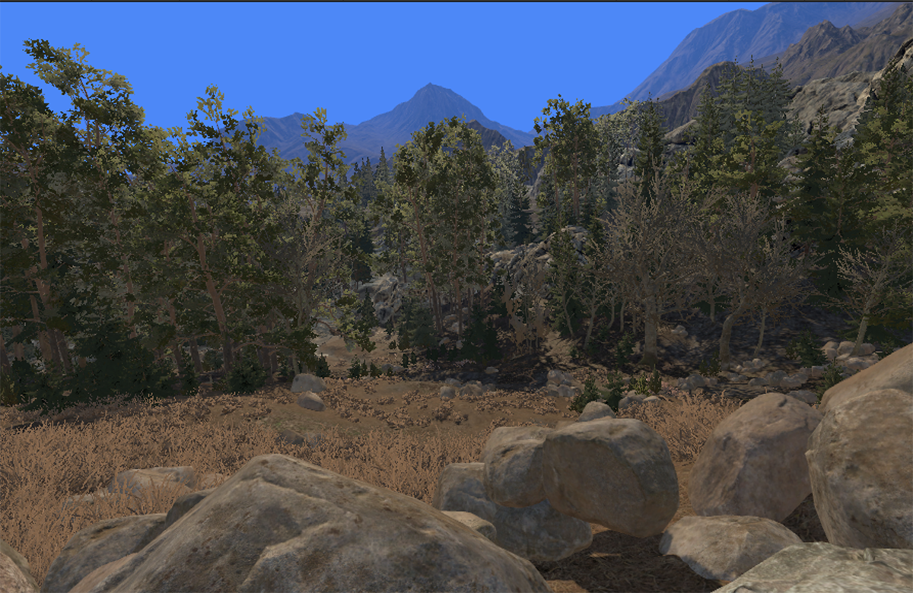
Figure 14.21 - Finding your way down the mountain isn't all that difficult if you have an unobscured view of your surroundings at a reasonable distance. However, in machine learning, peering too far in the distance means computing too many possible parameter variations to be practical or even possible.

14.36 - Descending the Scottish Highlands
Before we break out the graphs and formulas, an analogy of what gradient descent is all about might introduce the concept in a more familiar scenario. Imagine you find yourself lost in the Scottish Highlands when a heavy fog sets in. Without the fog, you could easily find a promising direction down the highlands towards the road below. You would just do a 360 around your environment (note that, with perhaps a few exceptions, it is a reasonable assumption that finding your way down in the highlands will eventually lead you to a road). However, with the fog, you can't see more than about 10 feet in front of you. How do you decide which way to go in this scenario? The best strategy now is to use a very local estimate of the overall downward direction could be.

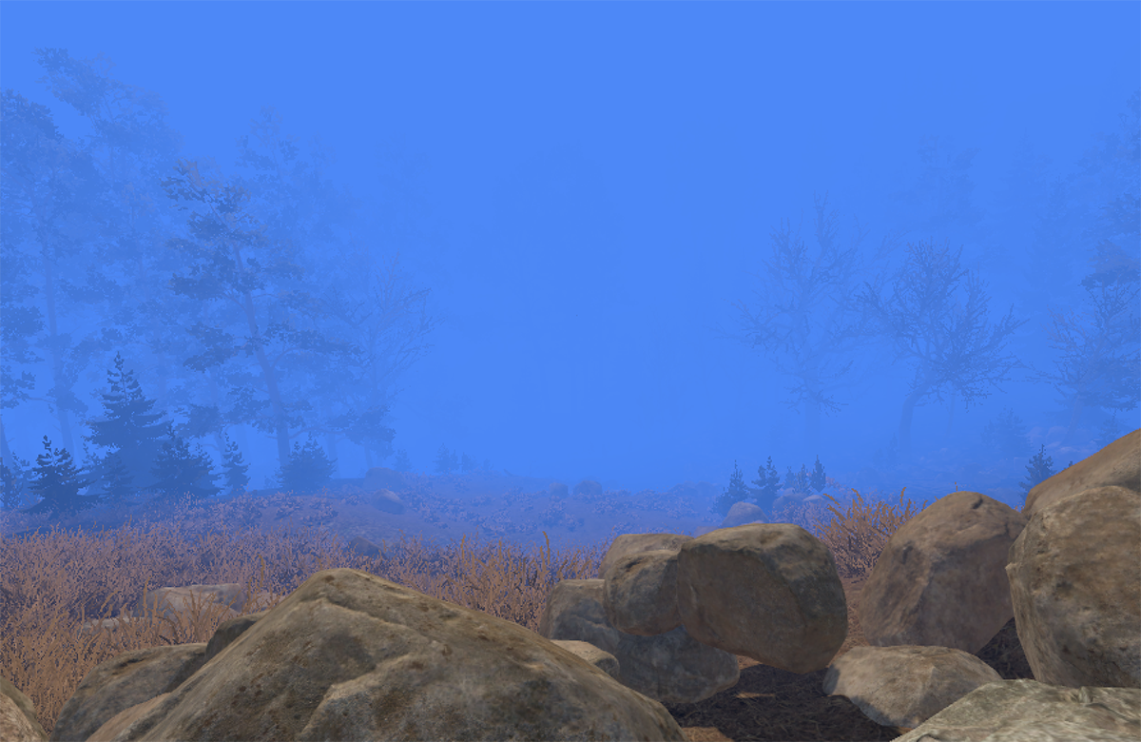
Figure 14.22 - Gradient descent uses local information to find a way down the mountain, acknowledging that the loss landscape some distance away is shrouded in computational 'mist'.
Rather than using distant cues to determine the way down, you estimate the local orientation of the surface you are standing on. Here's how you would do that. First, look to your immediate right and note how higher or lower it is relative to you. For argument's sake, imagine it is exactly one foot higher. Now, look to your left. This time you will find it to be slightly lower, by precisely one foot at well. From this, you can estimate you are currently at a roll angle with the surface. You can do the same by looking forward and behind you, finding that looking forward, the elevation is 2 feet higher, and behind you, it is 2 feet lower. Therefore, you are also at a pitch axis angle with the surface. You can construct the plane orthogonal to the surface you are standing on from these two directions. Keep in mind that this is only true for our current location. We can't extrapolate beyond our limited viewing distance. It is possible things might look very different somewhere further ahead. Based on this information, where do we decide to go next that we feel constitutes a descent? Well, it is lower to our left by a factor of 1 and lower behind us by a factor of 2. Therefore, the biggest descent we can realize is to move 1 unit to the left and two units backwards. In other words, the biggest gradient or slope points slightly to the left and a bit more behind us, so we decide to descend in that direction. Hence: gradient descent. When we commit to a direction and bravely move in it, we move a bit further down the mountain. However, when we move a certain amount in any direction, that direction may stop the optimal direction to pursue further. We will need to estimate the direction associated with the largest gradient and thus the biggest descent again after each step. In general, gradient descent relies on a certain smoothness of the underlying loss surface, and we can argue that the highlands are smooth at a relatively small scale. A meadow of gentle curvature usually does not abruptly transition into a vertical wall often (Nature offers some interesting counterexamples of this idea of smoothness, see below). But the highlands aren't exactly completely smooth surfaces either. If you look 3 feet in some direction, it might appear to be the best direction down the mountain. Still, once we get there, we can discover we were let astray: what looked like steady descent into the valley below was nothing more than a slight local indentation in the surface. For this reason, despite the smoothness, we will need to continue to take baby steps, first picking a direction to move towards, moving in that direction for a bit, and then re-evaluating whether that direction is still the right choice. When we replace our analogy of the Highlands with a surface created by the loss associated with different parameter settings, we refer to the slope at a particular point on the surface as the gradient

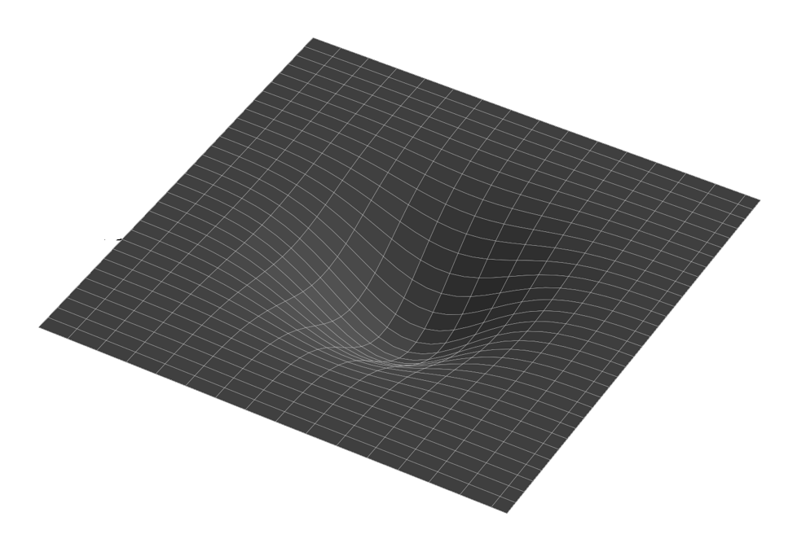
Figure 14.23 - If the gradient is positive in every direction, indicating that the loss will increase no matter where we go, we might have found the best possible solution. It is also possible we find ourselves in a local optimum.

14.37 - Getting stuck
The highlands analogy also reveals a potential pitfall in gradient descent: it can get stuck. You will appreciate the word pitfall, as it is a literal description of what can happen. Imagine we just stepped in the right direction, as indicated by the gradient. Of course, we will never retrace that step. Because from our current position, the location we came from will have a positive gradient associated with it, meaning we would have to ascend. Fine, we will just find another way forward and downward. But what is in every direction the gradient points up? In other words, what if we find ourselves at the bottom of a small convex indentation of the surface? It is problematic to the algorithm because one of two things could have happened. First, we arrived at the lowest point possible! We made it down the mountain! Pints all around! Or, in slightly more modest machine learning terms: we have found the optimal set of parameters for our model. There is no better solution; this is the best model we can theoretically get. However, it can also mean we are still very much up on the mountain but just settled into a small undulation where, from our perspective, the only way out is to go up. This is the problem of local minima in gradient descent. It cannot be solved or corrected with some magic bit of mathematics. The effects can be mitigated to some extent, however. Two approaches are typically used and combined. First, we adjust the amount of training data used on each iteration to update the weights. Using fewer data points to estimate the gradient makes the gradient less reliable. Our path through the loss landscape becomes more erratic, with bigger jumps between parameter values, although not always necessarily in the right direction. Such erratic behavior can prevent an algorithm from settling into a local minimum, as there is enough noise left in our gradient estimates that we might occasionally find ourselves jumping out of our local minimum. The downside, of course, is that it is hard to tell when we should consider not being so erratic because we may have found our global minimum already and just keep jumping out of it and back in again, like a machine learning version of Groundhog Day. This is addressed by the second approach, which changes how the algorithm makes updates over time. Based on the physics of how materials can end up with different properties based on the way they were cooled down from a hot state (like iron casting), these methods tweak the gradient descent algorithm to be more erratic early on and have more stable and smaller updates during later phases of training. We will discuss the first methodology later in this chapter when we contrast gradient descent, batch gradient descent, and stochastic gradient descent. Discussing the different training regimes will have to wait until we start working with deep belief neural networks in Chapter 22 and onward.

14.38 - Computing the gradient
Translating this back to machine learning and space consisting of parameters and associated losses, rather than rolling hills and men in kilts, looking left and right means considering a slightly higher or slightly lower setting for one parameter while looking forward and behind us represents a potential increase or decrease in another parameter. In mathematics, the gradient associated with one parameter is said to be the gradient with respect to it, commonly abbreviated as wrt. In the case of 2 parameters, this gradient is with respect to both parameters. Think of it as an angle point along the direction of both parameters differently. Changing only one of them may lower the loss for our current set of parameters but changing the other has little to no effect. Or perhaps increasing parameter a while at the same time decreasing parameter b will yield the biggest decrease in loss. A gradient thus has a direction along the axis of the space formed by our parameters. For our two-parameter model, this direction can be expressed by an angle, which in turn can be decomposed to the part of the gradient that is with respect to one axis (say the axes of a parameter a and the part of the gradient that is with respect to the other axes (parameter b). In addition, each direction also has an amplitude associated with it. This amplitude conveys the amount of descent we accomplish by moving along each axis of our parameter space. Sometimes, changing one parameter causes a much more significant decrease in loss. Sometimes, a change in the other parameter will do the trick. And in some cases, no matter where we look, no direction yields a lower loss. We find ourselves at the bottom of a valley in the latter scenario. If the parameters we found there meet our criteria for a successful model, we can stop the process of trying to update our weights. But we may be stuck in some local, swallow minimum. All around us, the slope appears upward, but only as far as we can see in that direction. Beyond it are deeper valleys associated with more optimal parameter solutions. We should consider getting ourselves unstuck and continuing our search.

14.39 - Computing the gradient - 1D example
Now that we have an intuition for using the gradient to guide us to a hopefully optimal set of parameters, we will need a way to compute it. It runs out, it isn't all that complicated, and we could just give you the formula and move on. Instead, we will take some time to try and convey exactly what is computed and why. And perhaps the best way to start is to consider trying to fit a single parameter: the slope of a linear function. Our function is as straightforward as they get: y = 2x + b. Using that function, we create some synthetic data completely noise free. The slope of 2 is the parameter we would like to estimate using gradient descent, given that we only have our input data x and output data y. We use gradient descent simply to figure out the best fitting function that transforms x into y, which hopefully turns out to be the function that generated it, which uses a slope of 2. Using the equations established earlier, we can compute the loss for a range of values that could be our slope. In our example, we set that range between 0 and 4. In this example, we map the entire loss landscape. When plotted in its entirety, it seems obvious what our parameter should be: the value of a at the lowest loss, which is indeed 2. Again, this stops being a way forward for more complicated models where the loss landscape is large and more importantly very highly dimensional. It simply becomes impossible to compute it in its entirety. Instead, we will have to work locally and use a guided approach for moving through the loss landscape, aiming to find a low point that yields an optimal result. In our example, we initialize our guess for the slope a to 3.5. What we need to compute at the point in our loss landscape is the gradient, or derivative of our loss function, weighted with how much that gradient contributed to the error we observed between what we predicted with a parameter at that point (a = 3.5) and what the actual outcome was. We can rephrase these two things as 1) in what direction should I move, or should I add a little or subtract a little from a to do better? and 2) how far should I move in that direction? The latter is important because if our current estimate of a doesn't cause any error in our prediction, why even move away from it, despite where the gradient might point?


Figure 14.24 - Animation of gradient descent fitting a 1-parameter model using a relatively small learning rate. Optimization is somewhat slow but stable, landing us nicely at the global minimum of our function where a=2.

The error is easily computed in linear regression: the difference between the predicted and actual outcome for each data point we use to compute our gradient descent update this time. The derivative isn't much harder to compute, although it takes a bit more math and insight. You might remember from your math classes that the derivative of a function at a particular value gives you the slope of your function at that value. Visually it is the straight line tangential to that function. Does that mean we should take our rulers out and draw it? Not really, because we know what kind of function we must deal with for our loss function. Looking back at the equations, you will find that the loss is computed from our inputs through squaring. That makes our loss function quadratic with respect to our input data. And what is the derivative of a quadratic function? That's right, a linear one. Putting that all together means that the derivative of the loss function we need to compute the gradient is the input data x itself. Again, since the loss function is a quadratic mapping of the input data, the derivative of that loss function simply takes us back to that input data. Let us put all of that together in one iteration of updating a based on all values of x in our data. You can find this in Table 2 and Equation 14.23

Figure 14.25 - The same as 14.24, but now with a larger learning rate. Note how we overshoot the global minimum on each iteration, although this overshoot eventually drops away, and the global minimum is reached.

14.40 - Computing the gradient - 2D example
Let's try a model with two parameters to generalize our gradient descent to more than just a single parameter. From there, it should be clear how we can, in principle, keep adding more parameters as long as we have enough data. Figure 14.21 shows a two-parameter function consisting of a slope a and an offset b fitted using gradient descent. And again, the animation highlights how the learning rate affects our descent.

14.41 - Learning Rates and Convergence
One key parameter we need to set prior to training is the learning rate. When we compute the gradients by combining our input data X with the errors they generate in predicting y, we adjust our parameters by a fraction of the computed gradients. We do this because we realize that the local gradient we compute is a very myopic estimate of what is happening at a large scale. We will get a direction we should move in, but this is only valid locally. A bit further out, the gradient might be very different. In other words, the gradient shows us the way but cannot tell us how far to go. Therefore, gradient descent uses small baby steps, updating the parameters by a fraction of the gradient. The parameter that determines this is called the learning rate and is typically denoted as alpha. If the learning rate is too small, it will take a long to converge. However, if the learning rate is too large, we might keep overshooting our target for some time and sometimes never converge. Selecting the correct learning rate is done by intuition and trial and error. As we already briefly outlined above, in more complex modern learning paradigms that train very complex deep belief neural networks, the learning rate is usually adaptative, changing over time based on how learning is progressing.

14.42 - The Gradient Descent Algorithm
We have now defined all the necessary components of the gradient descent algorithm. What remains is to put them together. The following is Python code for conventional gradient descent, annotated with the corresponding equations it implements. Weights are updated on each iteration by considering the entire training data set. As we will see shortly, there are alternatives to this approach, with some benefits. We assume that the algorithm will receive as input training input data X_train with m rows (examples) and n columns (variables/regressors), training ground truth output data y_train (with m rows) and 1 column. Although y_train is technically a vector, having it represented as a matrix of mx1 simplifies operating on it, especially when using other matrices. In addition, we will have a testing dataset consisting of X_test and y_test for objective assessment of the true objective loss for our model.

//Import NumPy for all matrix operations
import NumPy as np

//If X_train and X_test do not have a constant column to //function //as a bias, add one.
B_train = np.ones((X_train.shape[0],1))
B_test = np.ones((X_train.shape[0],1))
X_train = np.hstack((X_train,B_train))
X_test = np.hstack((X_test,B_test)

//Get and parameters
no_regressors = X_train.shape[1]
no_training_examples = X_train.shape[0]
learning_rate = 0.001
no_iterations = 100
loss_history = []

//Init Weights with small random weights theta. Again, //making theta a nx1 matrix makes operating on it much //easier.
theta = np.random.random((no_parameters,1)) * 0.01

//Loop through the maximum iterations
for i in range(no_iterations):

//Compute the y_pred using theta and X_train
y_pred = np.dot(X_train,theta)

//Compute the error
error = y_train - y_pred

//Compute the loss
loss = np.sum(error**2) / no_training_examples

//Combine gradient and error and normalize
G = np.dot(X_train.T, error) * (-2/X_train.shape[0])

//Update the weights
theta = theta - (G * learning_rate)

//Store loss for plotting purposes
loss_history.append(loss)

Code Snippet 14.3 - Gradient Descent in Python

And that is it. Things will get slightly more complicated as we move from regression to classification in the next chapter, but all the basic building blocks for training a modern machine learning model are there. And, as we will see later, most of this algorithm is still at the core of even the massive deep belief neural networks used today.

14.43 - Initial Parameters
Hopefully, the initial parameters we set for our parameters all lead to the same global minimum, but there is no guarantee they will. Thinking through what good starting values are can help overcome these issues. Additionally, it is not a bad idea to train an algorithm multiple times with different initial parameters. If all yield similar parameters upon convergence, our trust in the algorithm grows substantially.

14.44 - Different Training Regimes
Another critical decision that potentially impacts the parameters and the quality of the model after training is how we group different examples in our training data. At one extreme, we use all available training data to compute an aggregate gradient, which we already discussed and wrote pseudocode for. This has the benefit of being relatively stable, but since it is the average across many points, it tends to move the needle only by a little in terms of how much we update our parameters. In addition, for large data sets, computing the gradients for all data points becomes computationally expensive. Perhaps we can get away with using only a fraction of those points on each iteration?

14.45 - Stochastic Gradient Descent
The other extreme, referred to as stochastic gradient descent or one-shot learning, is when we iterate over each data point individually, compute the gradient for that data point only and update the parameters accordingly. If there is any noise in the data, the updates to our parameters will look quite erratic, changing direction at each update. Such erratic behavior might seem harmful, but it does have one substantial benefit. Because of the erratic nature of the parameter updates, we explore a far bigger extent of the parameter space. This can prevent us from getting stuck in local minima, as we can jump out of them just by virtue of the noise in our data.

14.46 - Batch Gradient Descent
Batch gradient descent is a good compromise, but determining the right balance requires intuition and testing. It is usually best to find some middle ground between the stability of using the entire data set or the exploratory nature of stochastic gradient descent. We can do this by grouping our data into batches, using only a percentage of the data on each iteration to update the parameters. It is traditional to call the iteration through a single batch of data an epoch.

14.47 - Hyperparameters
All these settings described above require some tweaking for our data set. Our choice of the learning rate, batch size, and the number of epochs are collectively referred to as hyperparameters. Later we will learn additional hyperparameters, such as dropout and regularization constants, but the principle is the same. Modern machine learning platforms and solutions will typically train models many times over, using different values for the hyperparameters. By mapping out the space of different hyperparameter settings, we can find hyper-minima, locations where specific learning rates and batch sizes result in better-trained machine learning algorithms.

14.48 - Overfitting and Underfitting
Linear regression models represent almost the most fundamental and most straightforward relationship between two variables: a linear one: the output y increases or decreases as a linear weighted fraction of the input x. However, noise in the data can still trip up a linear regression model. Most importantly, it can falsely assume that a particular noise pattern is a true signal, and the resulting function fitted on that data will reflect that. However, our model will fail when we apply that model to a new data set where that noise pattern isn't present. This is the classic case of overfitting: our model put too much faith in the data it was trained on. The way to circumvent this is by using training and testing data. We compute the loss for the training and testing data at each iteration. Initially, both will decrease as the model starts to capture the actual relationship between training and test data and all data. However, at some point, the model might start to overshoot that target and begin to fit the noise in the training data. At this point, our loss functions will diverge. For the training data, it will continue to decrease, making it seem our model is getting better and better. However, things get worse for our testing data: the model is now so tuned to the training data and its idiosyncratic patterns that it starts to fail on the testing data. It is always a good idea to closely examine the loss function for training and testing data. Typically, the point where the loss function starts to diverge is the natural stopping point: beyond that point, we start to harm our ability to generalize beyond our training data.

14.49 - Conclusions
We covered a lot of ground in this chapter. Many machine learning ideas and methods are interwoven and borrow from other disciplines almost freely. Bringing all of that together, in one place, in a (hopefully) somewhat coherent story requires a fair share of words, paragraphs and pages. It also benefits greatly from you, the reader, trying out some of the methods we discussed. Working through the notebooks with the data provided, and perhaps with the data you find yourself, should give you hands-on experience and a good understanding of the fundamentals without necessarily needing the exact mathematical derivations and proofs. Many toolboxes purposely hide a lot of detail to help people quickly develop machine algorithms. But the more these algorithms are hidden from view but can be used with the click of a button, the less we eventually understand what is truly working and when it is truly not working. It is somewhat reminiscent of a famous piece of software designed specifically to allow users to run many statistical analyses on their data. If you wanted, you could select all tests and see which one gave you the desired result, despite most tests not being valid in the context of your data. There are some optimistic and pessimistic estimates of how many scientific experiments have used incorrect statistical methods as proof, rendering the result, even though peer-reviewed, essentially without any scientific merit. Suffice it to say, it is a number larger than we probably feel is ever acceptable.

14.50 - Demo Notebooks and Playgrounds
The notebooks are organized to follow closely the introduction of concepts throughout this chapter. As a result, there are quite a few of them. Here, you can find a list of paragraphs and their associated demo notebook.

14.51 – References
- Gurnsey, R. (2017). Statistics for Research in Psychology: A Modern Approach Using Estimation. United States: SAGE Publications.
- Michalski, R. S., Banerji, R. B., Anderson, J. R. (1983). Machine Learning: An Artificial Intelligence Approach. Germany: Tioga Publishing Company.
- Murphy, K. P. (2012). Machine Learning: A Probabilistic Perspective. United Kingdom: MIT Press.
- Hespanha, J. P. (2018). Linear Systems Theory: Second Edition. United Kingdom: Princeton University Press.
- Provost, F., Fawcett, T. (2013). Data Science for Business: What You Need to Know about Data Mining and Data-Analytic Thinking. United States: O'Reilly Media.
- Rieke, F., Warland, D., Bialek, W., De Ruyter Van Steveninck, R. (1999). Spikes: Exploring the Neural Code. United Kingdom: MIT Press.
- Van der Plas, J. (2016). Python Data Science Handbook: Essential Tools for Working with Data. United States: O'Reilly Media.

